

Salvation for the Willing

the Beit haShoeiva

From the days I began observing the Feast of Tabernacles with my parents and up through my mid-40’s, I would hear sermons at the Feast about the Last Great Day. Though I remember little about those sermons, I do recall that they always happened on the final – the 8th day – of the feast, which the church taught was not really part of the Feast, but was a separate festival in itself.

In these sermons, the preacher would often quote this passage our of the book of John –

NKJ **John 7:37-38** On the last day, that great *day* of the feast, Jesus stood and cried out, saying, "If anyone thirsts, let him come to Me and drink. 38 "He who believes in Me, as the Scripture has said, out of his heart will flow rivers of living water.“

Though I never really gave much thought to the meaning of what John was saying back then, I did begin to consider it when in 1999, my wife and I began hosting a Feast of Tabernacles site that we called “Season of Our Joy”. I began to examine this passage because then – as a festival coordinator – I wanted to make sure that what was being taught was correct. I began to question why – if the 8th day was a separate festival – did we call it the “last” day. What I learned from my studies has helped me better understand God’s timing of end-time events and how God intends to extend the opportunity for salvation to all mankind.

I began to ask myself “what did John hope to convey when he quoted Yeshua’s statement on that day? What did he know about the “great *day* of the Feast” that we – some 2000 years later – may have missed? What does the Bible actually say about this particular day?”

If we were to search the scriptures for another reference to the “great day” of the feast of Tabernacles, we would come up with – NOTHING! There is no reference to it – not in the Torah, the Prophets, the Writings, or any other place in the New Testament other than John chapter 7. No mention is made in Leviticus 23 that might elevate any day of the Feast of Tabernacles over another, and though we might want to claim that the day after the 7-day festival is “great”, it is hard to make a case that it is the “last” day since it is only a 1-day festival.

So what can we do? How can we find what John was meaning?

I believe we can know about this day, but to do so we will have to adjust our thinking away from being so “Greek-minded” toward being more “Hebrew-minded”. We will need to understand how the Hebrews look at time, and we will need to take another look at Yeshua’s view of Jewish tradition.

So in this message, I want to show that –

* The Hebrew culture, which is the culture of the Bible, treats time as cyclical, not linear
* Yeshua had no problem with Jewish tradition as long it did not contradict Torah
* Yeshua used a Jewish tradition to help teach how salvation would be offered to the world

Once a person sees the context in which Yeshua made His statement, the understanding of end-time prophecy and God’s plan for the salvation of all who are willing begins to come to light.

**Biblical Cycles & Time**

To help us understand the Hebrew concept of time, we will start by looking at the alternative (the Greek) understanding of it. In the Greek, time in linear. Time has a defined beginning and (in many Christian circles) a defined end. This is in some ways based on the understanding that if God created everything, then He also created time. Thus “time” could be illustrated as a straight line that has as clear beginning and a clear ending, such as in the illustration below.

In this illustration, I put an arrow on the right end of the timeline because many Christians (and Jews) believe that those who submit to the teachings of the Bible have the opportunity for eternal life. It is yet to be seen whether or not eternal life does indeed mean there will be an era where there is no time.

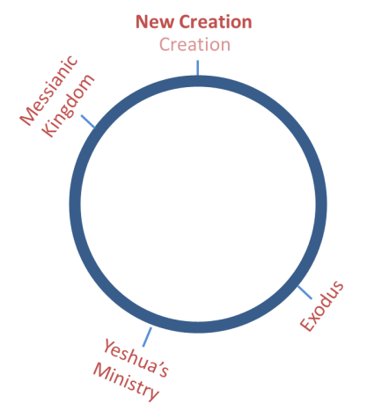On this timeline, I have noted major events that affect the lives of believers. In Greek thought, these would be one-time events, never to happen again. But in Hebrew thought it would be much different, for in Hebrew thought, time is cyclical — a cycle of events that tend to repeat themselves. This same timeline in Hebrew thought would look like the illustration on the right. It is a circle – a geometric shape that has no beginning and no end – thus time never ends. Not only does time not end, certain events in time repeat themselves. For instance, we all believe that just as Messiah Yeshua came to save His people about 2000 years ago, we know that He will return at the end of this age in the spirit of King David to establish His messianic kingdom on the earth.[1]

In like manner, just as YHVH gathered His people out of Egypt, the King will once again gather His people from bondage and bring them to the Promised Land[2], to a kingdom that existed before in the days of David and Solomon, only this time it will be an everlasting kingdom[3].

Bible students also understand that the creation that took place 6000 years ago was merely a type of a new creation that will take place at the end of the age[4] with purifying of the earth, the demise of death, and the coming of the New Jerusalem. Though we don’t know the exact timing of these events, they will likely occur in the same order as before.

What we can see is that in Biblical thought, time is a cycle of events, and according to King Solomon –

ESV **Ecclesiastes 1:9** What has been is what will be, and what has been done is what will be done, and there is nothing new under the sun.

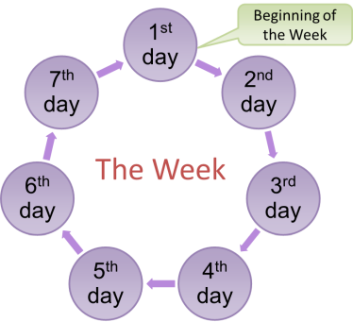This should be quite encouraging since we can see what is happening now by taking note of what had happened in Biblical history before.

Let’s now look at a number of other Biblical cycles. We’ll start with the seven-day week. Though Gregorian calendars show the week as a series of blocks laid out in rows of seven, a better illustration of a week is a circle where when the seventh day has ended, a new week starts again with the 1st day. This brings us to a very interesting point of scripture, that being that the day after the seventh day is not only the first day of a new week, it could be considered to be the 8th day of a seven day cycle. What do I mean by that? Simply that each NEW week begins on the 1st day, but in the concept of a cycle, that 1st day could also be considered to be an 8th day in the cycle. What that means is that in a seven-day cycle, the 8th day is always a beginning — we might call it a “new beginning”. That should spark your interest because in the Bible, there are a number of “new beginnings” that happen on the “8th” day. For instance:

* Circumcision happened on the 8th day of a male child’s life (Lev. 12:3)
* The firstborn of a woman was redeemed on the 8th day (Ex. 22:29)
* The Aaronic priesthood began after Aaron and his sons consecrated themselves for seven days. (Lev. 9:1; Num. 6)
* A leper would be considered clean on the 8th day, thus allowing him to come back into the camp of Israel.(Lev. 14:10)
* A Hebrew child receives his or her name on the 8th day (Luke 1:59)

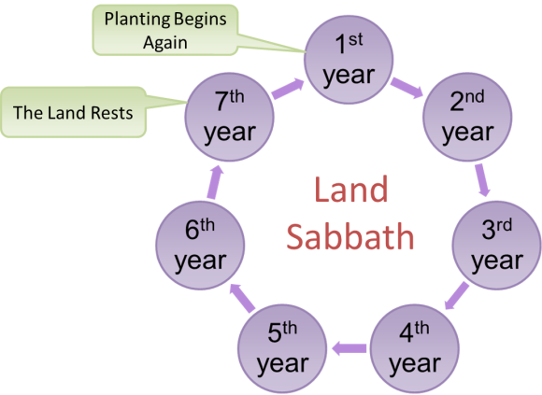As you can see, a lot of things happen on the “8th day”, and there are probably more events than just these including the fact that most Bible students see this age going for 6000 years, followed by a 1000 years “messianic” kingdom, which will then be followed by a “new heaven and new earth” – a New Beginning!

Let’s look at a few more biblical cycles that have an 8th day significance. We’ll start with the Land Sabbath where you raise and harvest crops for six years, let the land rest for one year, then begin planting again on the 8th year, which is understood to be the first year of the next cycle. In this context, the first year of that next cycle is a New Beginning because it marks the beginning of the planting portion of the cycle.

Another example is that of Shavuot – the Feast of Weeks. Many Bible students understand Shavuot to be a count of seven seven-day weeks that 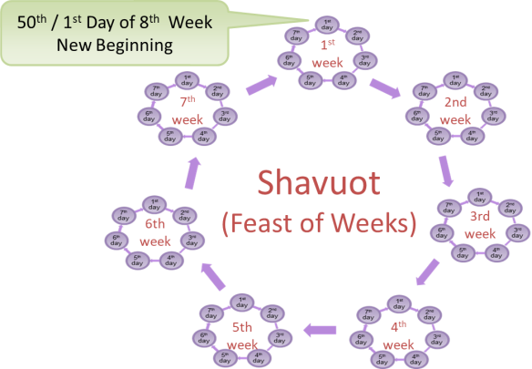all start of the 1st day off the week. By the end of that seventh week (which falls on the Sabbath) you will have counted 49 days, but because Shavuot falls on the 50th day, that day will always be on the 1st day of the week. It is a New Beginning, and[5] in Biblical history, that 50th day was the day YHVH took Israel as His bride. On that day, they became His People. It was a new beginning for the nation of Israel.

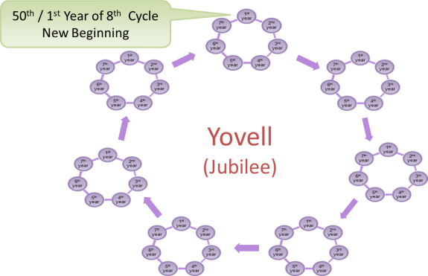Before leaving Shavuot, you will notice that the 50th day – the 1st day of the next week is not a stand-alone day. In other words, it is the first day of the next 7-day week. The weekly cycle did not change for the sake of that 50th day. Keep that in mind as we go to the next example – the Jubilee cycle.

The Jubilee is very similar to that of Shavuot except that instead of seven cycles of seven days, we are counting cycles of seven years. Though many believe that the Jubilee year is a stand-alone year (i.e. – not part of the next cycle), if we were to follow the example of all the previous cycles, the Jubilee year would be the 1st year of the next 7-year cycle of years.

The Jubilee represents freedom for the Hebrew slaves and the restoration of the Land to its original inheritors. Thus the Jubilee is a New Beginning for the Hebrew people – a new lease on life, both physically and economically.

The final cycle that we will look at is the yearly festival cycle, which in many believer’s view pictures the plan by which YHVH will bring salvation to all those who are willing to follow Him. The festivals represent events that have already taken place (and thus did or will likely happen again) and those that are yet to happen. They also represent the three harvest seasons in Israel, the season of barley, the season of wheat, and the fall general harvest that included the grape harvest.

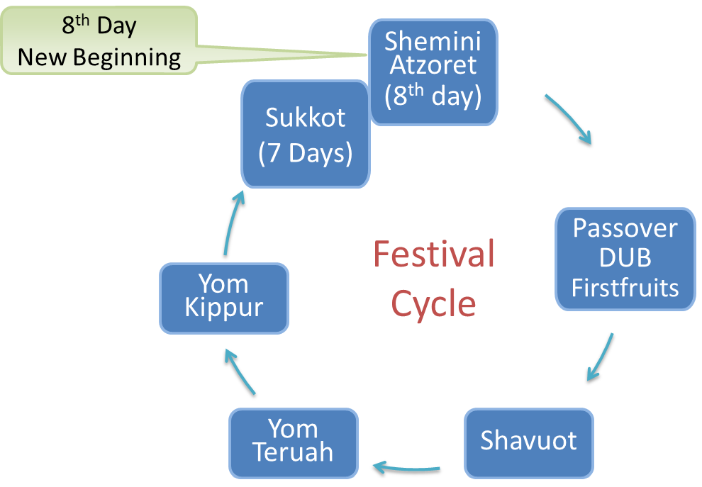

The illustration at right depicts the festivals in the order in which they occur. It does a relatively poor job illustrating the actual festival timing because the festivals vary in length and because there is roughly six months between the final festival and the beginning of the next cycle. Furthermore, there is no festival that depicts the creation of the world though some believe the world was created on Yom Teruah[6].

Nevertheless, the illustration will fit our purposes because what I want to depict is that if there was a festival that depicts the creation in its original state of perfection – the time between when God created Adam[7] and when Adam sinned – that festival would coincide with Shemini Atzoret, the festival that falls immediately after Sukkot – which many call the “8th Day of Sukkot”. In Judaism, this day pictures the beginning of the “Olam HaBa” (the world to come).

As mentioned earlier, It is widely understood that the seven-day festival of Sukkot pictures the 1000 year Messianic Kingdom that will begin at the close of 6000 years of man’s reign over the earth. The purpose of the Messianic Kingdom is to bring mankind back to the state of perfection in which Adam was created. Once that is accomplished, a New Beginning will take place — the earth will be cleansed with fire and the New Jerusalem will arrive. It will the “8th” year of a 7 – one thousand year cycle – the beginning of a new cycle for the earth and all mankind – that is, unless time ceases to exist altogether.

To summarize what we’ve seen regarding “Biblical” time:

* God illustrates His plan using cycles
* the “8th” day of most cycles marks a “new beginning”

Let’s now take a brief look at Yeshua view of Jewish Tradition

**Yeshua and Tradition**

When John wrote his account of the words Yeshua spoke at His last Feast of Tabernacles, he used the terms “last day” and “great day” rather matter-of-factly. He dropped them into the context of his letter as if he knew his readers would know exactly what he was talking about. But as mentioned earlier, the terms “last great day” are never mentioned in the Tnakh[8], which at the time of his writing, was the entirety of the Bible. So where did it come from? It had to be part of the Jewish tradition of the day. After all, John’s account of Yeshua’s life was written for the Jews.[9] Therefore, if we hope to understand what John was saying, we must understand a little about Yeshua and Jewish tradition.

Traditional Christianity generally holds a negative view toward Jewish tradition. They support that view based on some of Yeshua’s statements such as –

ESV **Matthew 15:6** “… So for the sake of your tradition you have made void the word of God …”

ESV **Mark 7:8-9** You leave the commandment of God and hold to the tradition of men." 9 And he said to them, "You have a fine way of rejecting the commandment of God in order to establish your tradition!

It is interesting to note that the above examples both reference the same event, and that in this and other places where Yeshua seems to be attacking their traditions, He is more correctly attacking their hypocrisy in regards to how they sometimes apply their traditions and put them above the commandment of God. A more careful look at Yeshua’s attitude toward Jewish tradition reveals that He was OK with it as long as it was applied fairly and was within the context of the Torah.

Paul had a little to say about Jewish tradition as well. In his letter to the Galatians, he spoke of his zeal for Jewish tradition.

ESV **Galatians 1:14** And I was advancing in Judaism beyond many of my own age among my people, so extremely zealous was I for the traditions of my fathers.

Many teach that Paul abandoned those traditions after his Damascus Road experience, but a deeper study indicates that instead of Paul abandoning tradition, he simply abandoned the accepted rabbinical tradition of making sure that the teaching of the teacher (which Paul was called to be) fell in line with what other teachers were teaching. Paul stated that instead of immediately conferring with the other apostles; he spent as much as three years in the wilderness studying the scriptures to understand what Yeshua had called him to teach. Only then did he confer with Peter and sometimes James.

Instead of Paul abandoning tradition, Paul supported it and taught it to his followers. For instance, to the non-Jewish believers in the synagogue at Corinth, Paul wrote –

ESV **1 Corinthians 11:1** Be imitators of me, as I am of Christ. 2 Now I commend you because you remember me in everything and maintain the traditions even as I delivered them to you.

In the above case, that tradition had to do with the role of women in the congregation. Since the Torah has no specific instructions concerning women in the synagogue[10], Paul encourage the people to follow the Jewish tradition since it seemed to work in bringing order to the meetings.

Yeshua did the same in regards to Jewish tradition, especially when it came to the synagogue. One might realize this, but the synagogue system and it structure were simply Jewish tradition. The Bible nowhere references it, but Yeshua used it and its structured services to further His message[11]. In Luke’s account of Yeshua attending the synagogue on the Sabbath, we see Him participating if four Jewish traditions:

1. Attending the synagogue on the Sabbath
2. Participating in the weekly Torah and Haftara readings
3. Standing up when reading from the scriptures
4. Sitting down when giving commentary on them

These last two points are key to understanding what Yeshua was saying in Matthew 23 regarding the teaching of the scribes and Pharisees[12] in that it was protocol to stand at the reading of the scriptures, and to sit while commenting on them.

Yeshua also used the traditional rabbi-disciple system to not only train His disciples, but also to provide them a venue as they went from town to town spreading His message of the restoration of the Kingdom of God.

Many Christians fail to realize that even baptism was also an early Jewish tradition which marked, among other things[13], the point when a person converted to Judaism.

Another clearly Jewish tradition that Yeshua followed was that of observing the festival of Hanukkah.

ESV **John 10:22-23**  At that time the Feast of Dedication took place at Jerusalem. It was winter, 23 and Jesus was walking in the temple, in the colonnade of Solomon.

Though some will say that Yeshua was not there to celebrate Hanukkah, but was simply at Jerusalem at a time that coincided with the Jewish festival, the facts show otherwise. For instance, Yeshua lived in Capernaum, a small fishing village on the northern part of the Sea of Gallilee. Evidence indicates that Yeshua never went to Jerusalem except for the festivals defined in Leviticus 23. So why else would He make this 4-day trip in the middle of winter?

Based on what we’ve seen, Yeshua was not against all Jewish tradition. Instead, He used tradition as a way to further His message, — and He taught the disciples to do so as well. When you really think about it, all of us have traditions, and as long as we keep them within the context of God’s law, there is really no problem.

**The Feast of Tabernacles**

One more point we need to cover before explaining John’s reference to “the Last Great Day” is that we clearly understand that the Feast of Tabernacles is a 7-day festival; not 8 days as some believe.

The scriptures clearly state that the Feast of Tabernacles is seven days long –

ESV **Leviticus 23:34** "Speak to the people of Israel, saying, On the fifteenth day of this seventh month and for seven days is the Feast of Booths to the LORD.

Since it is only a seven-day festival, it stands to reason that the requirement to stay in booths lasts for only seven days as well –

ESV **Leviticus 23:42** You shall dwell in booths for seven days. All native Israelites shall dwell in booths,

Based on this understanding, it would not be out of the ordinary for those living in and around Jerusalem to return to their houses the evening after the 7th day of Sukkot — and this is what John, Yeshua’s disciple, said did happen –

NKJ **John 7:53** And everyone went to his *own* house.[14]

So what is the 8th day?

The festival that immediately follows Sukkot is called “Shemini Atzaret” which means “the 8th Day Assembly”, and as we’ve noted before, the 8th day is usually a “New Beginning”. Thus, for the sake of understand John’s “last day of the feast”, we can see that it clearly is the 7th, or “last day” of the feast, which is followed by another 1-day festival.

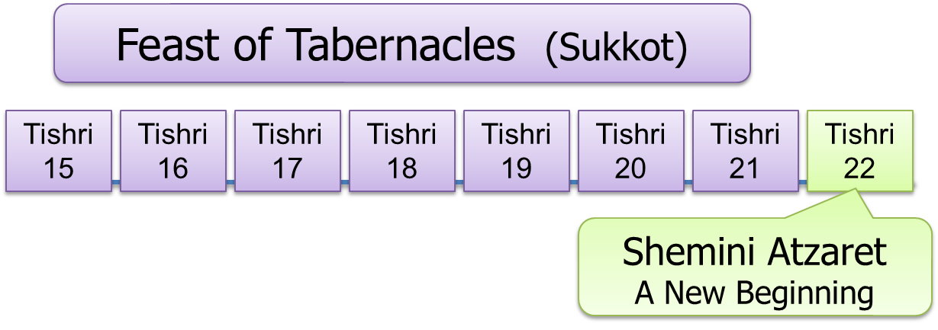

**The Last Great Day**

Armed with the background concerning Biblical cycles – especially the concept of the 8th day being a new beginning; and seeing that Yeshua was not necessarily opposed to all Jewish tradition, let’s now take a look at why John so matter-of-factly spoke of the “last day” – the “great day of the feast”.

The major theme of the Feast of Tabernacles is the Kingdom of God. For seven days, God’s people rehearse the joy of “the Kingdom” being restored on the Earth. Within that context comes the expectation that King Messiah, the son of David, will come and restore the Kingdom of Israel to its former greatness – a time when men endowed with God’s Holy Spirit would judge the people in righteousness.

Jewish history[15] speaks of a 1st century CE custom that took place every day during the feast of Tabernacles that portrays that expectation. It was called the “Beit haShoeiva” or “House of the Water Drawing” and would have been something Yeshua would have enjoyed each year as He observed the Feast of Tabernacles in Jerusalem.

Where do we find that custom in the Bible? Nowhere! The Bible nowhere defines it. It was simply tradition — a Jewish creation; but like most Jewish traditions, there was at least some Biblical basis.

The Jewish sages observed that God would oftentimes liken His Holy Spirit, as well as salvation itself, to water being poured out. They understood scriptures such as -

NKJ **Isaiah 55:1** "Ho! Everyone who thirsts, Come to the waters …”

and –

ESV **Isaiah 43:19-20**  “Behold, I am doing a new thing; now it springs forth, do you not perceive it? I will make a way in the wilderness and rivers in the desert. 20 The wild beasts will honor me, the jackals and the ostriches, for I give water in the wilderness, rivers in the desert, to give drink to my chosen people …”

as pertaining to the end-time return of the Hebrew people to the Land. They saw a salvation aspect as well based on scriptures like –

ESV **Isaiah 12:2-3**  "Behold, God is my salvation; I will trust, and will not be afraid; for the LORD GOD is my strength and my song, and he has become my salvation." 3 With joy you will draw water from the wells of salvation.”

These all pertain to the coming of the Messiah and the restoration of the Messianic Kingdom. They believed there would be a great “salvation” at that time followed by a great outpouring of God’s Holy Spirit as prophesied by the prophet Joel –

ESV **Joel 2:28-29**  "And it shall come to pass afterward[16], that I will pour out my Spirit on all flesh; your sons and your daughters shall prophesy, your old men shall dream dreams, and your young men shall see visions. 29 Even on the male and female servants in those days I will pour out my Spirit.”

Because of these connections, they were able to see that Joel’s “great outpouring “ of the Holy spirit would come at the latter part of the Messianic Kingdom, which of course is pictured by the Feast of Tabernacles.

The sages also believed that every word of the Torah was God-breathed; down to the individual letters and even the spaces between the letters. In their studies, if they saw something peculiar in the way a word was spelled or how a sentence was structured, they would ponder the meaning behind it and build a teaching or tradition based on that meaning, thinking God had put it there for a reason.

One such peculiarity happens in Numbers 29, the portion of scripture that deals with offerings during the Feast of Tabernacles. In that passage they found extra letters in some words, and when they put those letters together, they spelled “mayim”, the Hebrew word for water. So they developed a tradition centered on the need for water.

**The Water Pouring Ceremony**

Every morning during Sukkot, a group of priests would make their way to the Pool of Siloam, the spring-fed pool that sustained Jerusalem during the days of King Hezekiah. One of the priests would carry a silver pitcher full of wine, and another would carry an empty gold pitcher. Upon arriving at the pool, the priest with the gold pitcher would dip it into the pool and draw out a pitcher full of water. After drawing the water, the priests and their entourage would make their way back toward the Temple where they would wait at the “Water Gate”, an appropriately named gate on the southern part of the Temple complex.

While this was going on, other priests would gather long willow branches from an area north of the Temple and then head back to assemble at the Eastern Gate of the Temple. Along the way, they would waive their branches back and forth in unison so as to make a sound of wind in the trees – a portrayal of the “sound” of the Holy Spirit[17] coming to the people.

Because this all took place in the morning during the time of the Morning Sacrifices, a third group of priests would be attending to those services.

When both groups – those with the water and those with the willows – were in place, a trumpet was blown and the priests would proceed through the gates. As they approached the Altar, the two priests with pitchers would ascend the Altar and make their way to its southwest corner. At the same time, the other priests would circle the altar one time, after which a trumpet would sound and the priests with the water and wine would pour the contents of their pitchers into vessels on the Altar. At that point, the people watching would break forth with song and praise as the priests stood their willow branches against the Altar forming a covering over it. This took place each of the first six days of the festival of Sukkot, and was patterned after the conquest of Jericho some 1400 years earlier where the Hebrews circled the city one time a day for six days.

**Hoshanna Rabba**

On the seventh and last day of Sukkot, the same would happen except that the priests circled the Alter seven times before the trumpet was blown and the water was poured out – and like it was at Jericho, at the completion of the seventh circuit – as the water was being poured out – the people shouted with a loud voice.

Fourteen hundred years earlier, the walls of Jericho fell, signaling the “opening the gate” of the Promised Land. For the Jews in the first century, this event signified a great outpouring of the Holy Spirit and the salvation that would come to the Hebrew people. Thus this 7th day was appropriately called “**Hoshanna Rabba”**, the Great Salvation – a name based on Psalm 118:24, part of the “Hallel”[18] psalms of praise.

ESV **Psalm 118:25-29**  **Save us, we pray**, O LORD! O LORD, we pray, give us success! 26 **Blessed is he who comes in the name of the LORD!** We bless you from the house of the LORD. 27 The LORD is God, and he has made his light to shine upon us. Bind the festal sacrifice with cords, up to the horns of the altar! 28 You are my God, and I will give thanks to you; you are my God; I will extol you. 29 Oh give thanks to the LORD, for he is good; for his steadfast love endures forever!

“Save Us, we pray” comes from the Hebrew “hosheana-ana” – “save us now, we pray, we pray”, and though this part of the psalm was sung every day of the festival, on the 7th – the last day – all the Hallel prayers[19] were sung. Thus, the 8th day was a “great day” of praise!

In this psalm, we find this interesting passage – “Blessed is he who comes in the name of the LORD!”. This was the customary announcement for when the King came to town. You will recall that it was sung by Yeshua’s followers as He entered Jerusalem on a donkey during this – His last festival of Sukkot.

NKJ **Mark 11:1-10** Now when they drew near Jerusalem, to Bethphage and Bethany, at the Mount of Olives, He sent two of His disciples … 7 Then they brought the colt to Jesus and threw their clothes on it, and He sat on it. 8 And many spread their clothes on the road, and others cut down leafy branches from the trees and spread *them* on the road. 9 Then those who went before and those who followed cried out, saying: **"Hosanna! 'Blessed *is* He who comes in the name of the LORD!'**  10 Blessed *is* the kingdom of our father David that comes in the name of the Lord! Hosanna in the highest!“

That trip from Bethany is about a mile walk, and because of the terrain, would typically take about 30 minutes. By openly repeating that statement, the people were expressing their belief that the King was coming, and they believed Messiah Yeshua was that king. As king, they expected Him to take the kingdom by force and rid them of the scourge of the Roman occupiers. But that was not to be! It was not part of God’s plan.

Instead of overthrowing the Romans, He simply took part in the various festival activities like the rest of His Jewish brothers. One of those activities would have been the daily water drawing ceremony. So let’s imagine what John may have witnessed that morning on this “great day” of the feast.

**Yeshua Cries Out**

The setting is the Temple in Jerusalem on **the last and great day** of the feast of Tabernacles – a day the Jews called “Hoshanna Rabba “. It is approaching 9 AM and Yeshua, along with John and His other disciples, join the crowds carrying their somewhat dried willow branches as they make their way to the Temple. Yeshua had already chosen where he wanted His group to be – a place where they could see the activities going on around the Altar. As they arrive at their pre-chosen spot, the morning sacrifices are just beginning and the priests are exiting the Temple precincts on their way to gather water and willows.

As the sacrifices continue, the people begin to hear the swish-swish sound of the willow-bearing priests returning to the Temple area. They look to the south and see the excitement as the water bearing priests are also returning, making their way from the Pool of Siloam toward the Water Gate.

As the priests get in place, the trumpet is blown and the willow-bearing priests fall in behind the two carrying the water and wine. Together they march toward the Altar. As they approach it, the two leading priests veer off to begin their ascent of the Altar while those carrying willows march in an orderly procession around it – waving their willows back and forth as they go. All this time, other priests are continuing to perform the morning sacrifices.

Once on top, and holding their pitchers for all to see, the priests on the alter watch as their companions march around the Altar seven times, waving their willows and singing the Hallel psalms along the way. The swish-swish of the willows is now quite loud, but at the completion of the seventh circuit they all stop. There is silence as they await the sound of the trumpet signaling the priests to pour out the water and wine. Suddenly the trumpet sounds and the priests slowly pour out their pitchers onto the altar – just as they had done the previous six days. As the last drops of water and wine come out and the people prepare to shout, a familiar, but obviously amplified voice breaks out of the silence saying -

NKJ **John 7:37-38** … "If anyone thirsts, let him come to Me and drink. He who believes in Me, as the Scripture has said, out of his heart will flow rivers of living water.“[20]

With a smile, John looks to his Rabbi thinking “He truly is the King; it’s just a matter of time”.

On this Last Day, the Great Day of the feast, using the Jewish tradition called the “Beit haShoeiva” – “House of the Water Drawing” – Yeshua confirmed that the Jews were correct – the Holy Spirit would be poured out during the latter part of the Messianic Kingdom; salvation would come to Israel; and without publicly stating it, He confirmed to those who believed on Him (even to some who did not) that He was indeed the Christ – the Anointed King of Israel – the Messiah. Through Him there will be a “Great Salvation”.

What does that mean for us? It means God has a plan by which all who are willing will receive salvation and a place in the Olam Haba – the World to Come. That plan is hidden in the observance of the Biblical festivals, and as we continue to observe them and learn from them, He will make it plain for all to see.

Shalom Alecheim

1. Rev. 17:14
2. Jeremiah 16:14-16
3. Acts 1:6 indicates that the disciples understood that the Messianic Kingdom would be a restoration of a previous kingdom of which the Jewish people were well aware.
4. Rev. 20:1-5
5. According to Jewish tradition, but evidence indicates they are correct.
6. The Jews also call it “Rosh HaShannah” – literally “head of the year”
7. After God created Adam, He said that all He had created was “very good” (Gen. 1:27-31)
8. The Old Testament
9. Galatian’s 2:7-9;
10. The synagogue itself was Jewish tradition. It is generally understood to be a creation of the leading Jewish sages during the Babylonian captivity.
11. (Luke 4:16-20; Acts 13:15-15; Acts 15:21)
12. https://www.amiyisrael.org/articles/DustOfRabbi/dust-of-rabbi.html
13. Hebrews 6:1-2 shows that there were at least more than one purpose for baptism.
14. John could have been indicating that Yeshua’s detractors were the ones who returned to their homes, but if this is the case, it validates the fact that it was certainly permissible because Yeshua’s detractors were very pious.
15. Mishnah Tractate Sukkot 4:9 and 4:10
16. In the context of Joel’s prophecy, the outpouring of the spirit comes during the Feast of Tabernacles
17. In both Greek and Hebrew, the words for ‘wind’ and ‘spirit’ are oftentimes the same. Example: John 3:8
18. ‘hallel’ = “praise”
19. Psalm 113-118
20. A compilation of Isaiah 55:1, 43:19-21; 12:3